**1.Real Vehicle:**

**CCS 2017**

Viden: Attacker Identification on In-Vehicle Networks

该论文提出了一种新颖的方案，测量利用车载网络上普通ECU之间的细微差别电压来识别正常ECU和被攻击的ECU。在通过ACK学习阶段，Viden利用电压测量值来构建和更新正常变送器ECU的电压曲线作为其指纹。

**Testbed (prototype): 4 nodes. (Each node consists of an Arduino UNO board and a SeeedStudio CAN shield.)**

**Actual Vehicle: 2013 Honda Accord and 2015 Chevrolet Trax.**

**CCS 2018**

Scission: Signal Characteristic-Based Sender Identification and Intrusion Detection in Automotive Networks

本文名为Scission的入侵检测系统，该系统使用从CAN帧中提取的fingerprint来识别发送ECU。与viden不同，Scission使用差分信号代替高低信号，并且在变化的条件（例如电池电量或电磁兼容性）方面更可靠。

**(prototype): 10 CAN nodes.**

**--Five Arduino Unos and each equipped with two CAN shields.**

**-- Each ECU has a different stub length (2.45 - 13 meters) which can effect the voltage profile of the ECUs.**

**Actual Vehicle: Fiat 500 and Porsche Panamera S E-Hybrid.**

**Usenix Security 2016**

Fingerprinting Electronic Control Units for Vehicle Intrusion Detection

通过计算不同ID的消息的时钟偏移来分类不同ECU，从而判断有没有ECU进行

**CAN bus prototype;**

**真车**

**Honda Accord 2013**

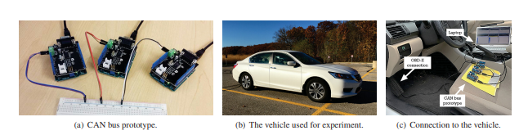

**Usenix Security 2019**

CANvas: Fast and Inexpensive Automotive Network Mapping

该论文主要是通过对汽车ECU的扫描，通过时钟偏移来MAP所有CAN 消息的来源。然后通过分别隔离ECU来查看所有ID的目的，依次做出车内CAN网络的拓扑。

**两辆全控制真车:**

**’09 Toyota Prius,**

**’17 Ford Focus,**

**三辆未控制真车：**

**’08 Ford Escape, ’10 Toyota Prius and ’15 Ford Fiesta**

**Ndss 2020**

EASI: Edge-Based Sender Identification on Resource-Constrained Platforms for Automotive Networks

主要是针对发送者ID的边缘电压特征，在降低采样率和计算资源的情况下，识别发送方的ECU

**CAN Bus Prototype--Arduino UNO Rev3+CAN bus shield**

**Real car: a Fiat 500 and a Porsche Panamera S E-Hybrid,**

**ACSAC 2019**

SIMPLE: Single-Frame based Physical Layer Identification for Intrusion Detection and Prevention on In-Vehicle Networks

一种基于ECU物理层的实时入侵检测系统。提出了多帧电压检测存在的漏洞，并且提出了单帧的分类方法，在每一位byte上提取不同的特征进行分类。

**CAN Bus Prototype：**

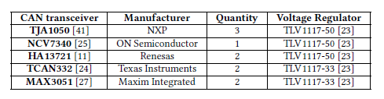

**Real car-- Nissan Sentra 2016 and Subaru Outback 2011**

BTMonitor: Bit-time-based Intrusion Detection and Attacker Identification in Controller Area Network利用了每一个bit发送的时间。

PS:1不同路CAN需要单独的检测仪器，网关会转播其他路CAN的数据。

2.明确做了实验证明OBD接口无法直接检测车内数据。

**CAN模型+真车**

**CAN Bus Prototype--Arduino UNO Rev3+CAN bus shield**

**Real Vehiclea--2012 Buick Regal.**

**VoltageIDS (TIFS’18)**

基于拓展帧的电压来fingerprint 具体ECU

**Testbed (prototype): 12 CAN nodes. (Each node consists of an Arduino**

**UNO board and a CAN shield from SeedStudio)**

**Actual Vehicle: a 2014 KIA SOUL, and a 2010 HYUNDA SONATA.**

**CCS 2019**

LibreCAN: Automated CAN Message Translator(并不是IDS)

这边是关于翻译车辆CAN消息的论文，主要核心思想是首先通过READ算法将消息分段。

然后第一步是将其中的sensor数据段与OBD协议获取的数据段进行相关。

第二步是通过车辆的具体行为将物理时间的命令找到。

**四辆真车**

**Four vehicles from the same OEM and they have acquired DBC files for all four vehicles.**

**CCS 2016**

Error Handling of In-vehicle Networks Makes Them Vulnerable

提出了一种根据CAN网络的错误机制来形成的物理攻击。

**CAN bus prototype:**

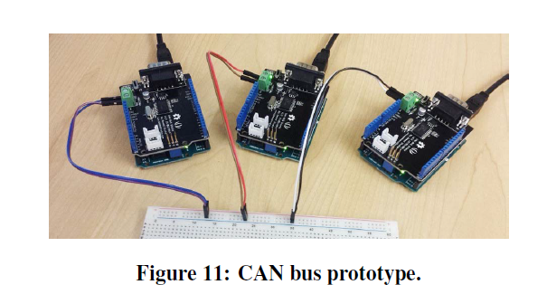

**2 real vehicle.**

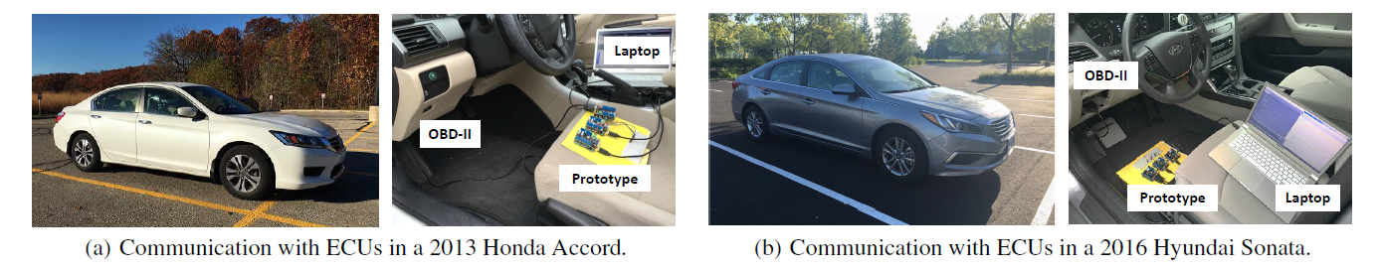

**Usenix Security 2020**

Plug-N-Pwned: Comprehensive Vulnerability Analysis of OBD-II Dongles as A New Over-the-Air Attack Surface in Automotive IoT

本文主要讲述了是市面上一些OBD盒子/设备存在的漏洞，会对车辆造成的危害以及提到了一些防护的建议

**真车+OBD-II Dongle**

**2015 Honda Civic automobile**

**Ndss 2020**

Hold the Door! Fingerprinting Your Car Key to Prevent Keyless Entry Car Theft

研究了无钥匙进入系统，利用了RF信号的fingerprint,设计了一种子身份验证系统，且不会影响现有的身份验证系统。就是对钥匙信号进行训练，识别出真正的RF信号

**真车实验**

**a 2014 Kia Soul and 2016 Volkswagen Tiguan**

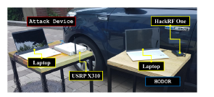

**Usenix Security2016**

Lock It and Still Lose It—On the (In)Security of Automotive Remote Keyless Entry Systems

研究了针对汽车远程遥控装置的攻击。他窃听了汽车钥匙的信号，研究了针对使用Hitag2 rolling code scheme所制造出来的车辆的攻击

**真车实验(各种车型)：**

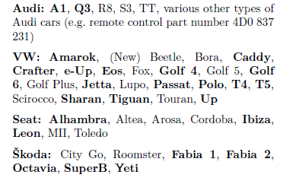

**CHES 2019**

Fast, Furious and Insecure: Passive Keyless Entry and Start Systems in Modern Supercars

记录并逆向了豪车中的无钥匙进入系统和启动系统，分析其中存在的漏洞。

**Tesla Model S PKES system**

**并且对该车的进入系统机型了攻击**

**IEEE TRANSACTIONS ON VEHICULAR TECHNOLOGY 2019**

Comprehensive Fault Diagnosis and Fault-Tolerant Protection of In-Vehicle Intelligent Electric Power Supply Network

对车载电源网络的故障诊断和容错保护

**真车和测试台**

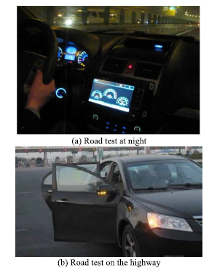

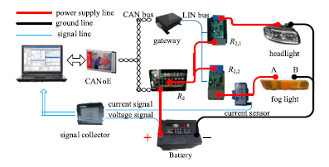

**IEEE TRANSACTIONS ON VEHICULAR TECHNOLOGY 2020**

Vehicle Detection and Classification Using Distributed Fiber Optic Acoustic Sensing

使用分布式光纤声学传感（DAS）的车辆检测和分类系统

**Experiments were carried out on the campus road of Beijing Jiaotong University.**

**(Real vehicle).**

**Usenix Security2020**

Losing the Car Keys: Wireless PHY-Layer Insecurity in EV Charging.

本文是描述了针对电动汽车的组合充电系统（CCS）的物理层进行了隐形的窃听，发现了很多隐私问题。

**三辆纯电动汽车经过总共54次充电**

**a BMW i3, a Jaguar I-PACE and a Volkswagen e-Golf.**

**2. CAN bus prototype:**

**IEEE TRANSACTIONS ON VEHICULAR TECHNOLOGY 2020**

MAuth-CAN: Masquerade-Attack-Proof Authentication for In-Vehicle Networks

这篇论文提出了一个种新的身份验证协议MAuth-CAN

**CAN bus prototype:** Raspberry Pi 3 Model B (1.2 GHz), Arduino Zero (48 MHz), CAN-BUS

Shield V1.2

**IEEE TRANSACTIONS ON VEHICULAR TECHNOLOGY 2020**

Highly Efficient Authentication for CAN by Identifier Reallocation With Ordered CMACs.

利用对CAN消息的ID进行设计验证算法来确保发送接收的正确。（增加身份验证）

**CAN bus prototype: NXP S12XF512 Starter Kit and two Infineon Application Kits TC224 and TC297.**

**IEEE TRANSACTIONS ON VEHICULAR TECHNOLOGY 2020**

Ensuring Safety and Security in CAN-Based Automotive Embedded Systems: A Combination of Design Optimization and Secure Communication

对CAN网络的重新设计来加强防御

**CAN bus prototype: Arduino M0 (48 Mhz) and SeedStudio CAN bus shield**

**IEEE TRANSACTIONS ON VEHICULAR TECHNOLOGY 2018**

Identifying ECUs Using Inimitable Characteristics of Signals in Controller Area Networks.

监听CAN网络的电信号特征，对于车内网络进行入侵检测,利用的是经过设计的拓展帧来进行ECU的区别

**CAN bus prototype:**

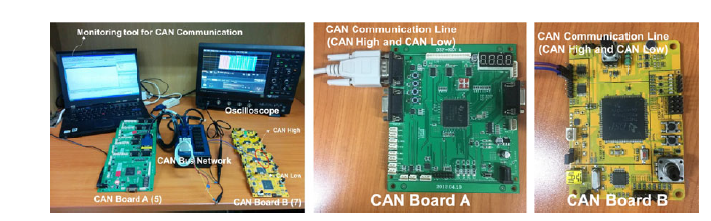

**ACSAC2017**

VulCAN: Efficient Component Authentication and Software Isolation for Automotive Control Networks

提出了一种用于车辆消息验证的通用设计，用计算机记住验证软件身份并隔离。

**CAN Bus Prototype--Xilinx Spartan-6 FPGAs**

**2019 4th International Conference on System Reliability and Safety (ICSRS)**

Lightweight Ciphers in Automotive Networks: A Preliminary Approach

本文研究了使用对称加密算法来保护由CAN协议交换的消息的可能性

**CAN prototype：Raspberry Pi 3 Model B Plus (B+)**

**Pattern Recognition Letters 2020**

Securing the internet of vehicles through lightweight block ciphers

本文研究了使用轻量级分组密码保护车载设备（如微控制器）的可能性

**CAN prototype：Raspberry Pi 3 Model B Plus (B+)**

**IEEE Access 2020**

TIDAL-CAN: Differential Timing Based Intrusion Detection and Localization for Controller Area Network

在本文中，通过考虑总线的固有延迟特性并通过监视两个总线两端的信号到达时间的差异，我们可以通过与位置相关的差分延迟来识别节点，并提供相关信息以估算发射器的相对位置总线上的节点

**CAN bus prototype:**

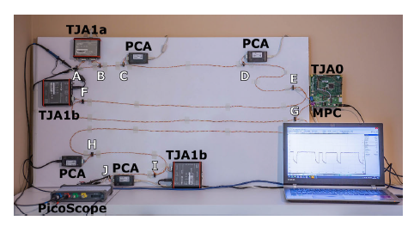

**IEEE TRANSACTIONS ON VEHICULAR TECHNOLOGY 2020**

Response-Time Analysis for Controller Area Networks With Randomly Occurring Messages

建立了一个新的模型来模拟非周期性CAN消息的行为，并判断相应时间

**The proposed method is validated on benchmarks and an actually executed RTA.**

**IEEE TRANSACTIONS ON VEHICULAR TECHNOLOGY 2019**

Quantitative Analysis of Ringing in a Controller Area Network With Flexible Data Rate for Reliable Physical Layer Designs.

对CAN-FD网络中的振铃效应进行分析

**CAN bus prototype: Ardudino**

**IEEE TRANSACTIONS ON VEHICULAR TECHNOLOGY 2019**

Tree-Based Intermittent Connection Fault Diagnosis for Controller Area Network

对于车内CAN网络的故障分析

**CAN bus prototype: FPGA**

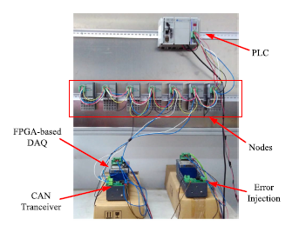

**IEEE TRANSACTIONS ON VEHICULAR TECHNOLOGY 2019**

Ringing Suppression in a Controller Area Network With Flexible Data Rate Using Impedance Switching and a Limiter.

本文是利用阻抗的选择和限幅器来抑制CAN-FD的振铃效应

**CAN bus prototype:**

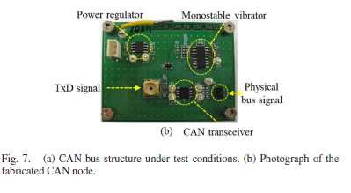

**IEEE TRANSACTIONS ON VEHICULAR TECHNOLOGY 2018**

Compatibility Analysis of the Turbo Controller Area Network (TURBO CAN).

对于一种结合了通带调制信号和CAN信号的新型局域网turbo CAN的。

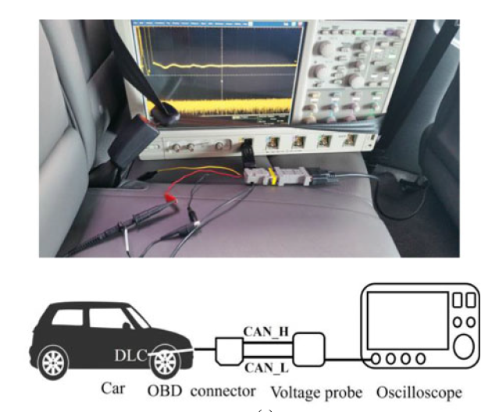

**通过测量真车数据来测量CAN内部的参数，然后建模**

**IEEE TRANSACTIONS ON VEHICULAR TECHNOLOGY 2020**

Sensor Fault Detection and Isolation Using a Support Vector Machine for Vehicle Suspension Systems

使用SVM 来验证车辆传感器是否存在问题



**A quarter-car test rig : the front suspension of a Hyundai Genesis Coupe (midsize coupe) is used**

**3. CAN Data**

**IEEE TRANSACTIONS ON VEHICULAR TECHNOLOGY 2020**

SAIDuCANT: Specification-Based Automotive Intrusion Detection Using Controller Area Network (CAN) Timing

CAN总线的实时模型参数，基于实时模型的异常监督学习

CAN dataset online

**ORNL.**

**IEEE TRANSACTIONS ON VEHICULAR TECHNOLOGY 2019**

Mobile Edge Assisted Literal Multi-Dimensional Anomaly Detection of In-Vehicle Network Using LSTM.

对车载网络特别是CAN网络的异常检测，通过数据域的64bit以及时间间隔interval合起来,形成一个64+1的特征输入、

**CAN data from vehicle**

**MDPI 2020**

A Kohonen SOM Architecture for Intrusion Detection on In-Vehicle Communication Networks

使用Kohonen Self-Organizing Map (SOM) ，使用监督的XY融合Kohonen网络（XYF），然后将XYF网络与K-means聚类算法（XYF-K）结合以提高网络效率

**纯数据推导：**

**Data online**

**Car-Hacking Dataset for the Intrusion Detection. Available online: http://ocslab.hksecurity.net/Datasets/**

**CAN-intrusion-dataset (accessed on 27 November 2019).**

**IEEE Access 2020**

CANet: An Unsupervised Intrusion Detection System for High Dimensional CAN Bus Data

这是第一个基于深度学习的入侵检测系统（IDS）

**Dataset from real vehicle**

**IEEE Access 2020**

Normal and Malicious Sliding Windows Similarity Analysis Method for Fast and Accurate IDS Against DoS Attacks on In-Vehicle Networks

在本文中，提出了一种可以利用两个滑动窗口的相似性来检测操纵熵Dos的攻击的方法.

**Dataset online**

[**http://ocslab.hksecurity.net/Dataset/CAN-intrusiondataset**](http://ocslab.hksecurity.net/Dataset/CAN-intrusiondataset)**.**

Detecting attacks to internal vehicle networks through Hamming distance

利用汉明距离检测恶意攻击

**2017 AEIT International Annual Conference**

**Data from CAN bus**

Sliding Window Optimized Information Entropy Analysis Method for Intrusion Detection on In-Vehicle Networks

利用滑动窗口的信息窗来检测异常攻击

**IEEE ACESS 2019**

**Data online**

**IEEE WF-IoT IEEE 2020**

Towards Reverse Engineering Controller Area Network Messages Using Machine Learning

创建一个机器学习分类器来分析消息并确定他们与其他消息和车辆的关系功能

**Dataset online**

**Oak Ridge National Labs, “User facilities at the National Transportation**

**Research Center,” https://www.ornl.gov/facility/ntrc/research-areas/**

**vehicle-systems, 2020.**

**IEEE TRANSACTIONS ON VEHICULAR TECHNOLOGY 2020**

Abnormal Driving Detection With Normalized Driving Behavior Data: A Deep Learning Approach

使用dep architecture models来检测异常行为

**Driving behavior data (DBD) are collected by instrumented vehicles of the General Motors Corporation.**

**They simulate the data based on the collected DBD.**

**IEEE TRANSACTIONS ON VEHICULAR TECHNOLOGY 2020**

Simulation Framework for Misbehavior Detection in Vehicular Networks

本文是研究V2X即车辆与周围设备组成的车辆网络，恶意的车辆行为造成的影响

**Simulation: VEhicles In Network Simulation**

**IEEE TRANSACTIONS ON VEHICULAR TECHNOLOGY 2019**

Detecting Vehicle Anomaly in the Edge via Sensor Consistency and Frequency Characteristic

使用了车内传感器的一致性和频率来检测车辆的异常行为

**Dataset online**

**Open sourcing 223GB of driving data, 2018. [Online]. Available:**

**https://medium.com/udacity/open-sourcing-223gb-of-mountain-viewdriving**

**-data-f6b5593fbfa5**

**IEEE TRANSACTIONS ON VEHICULAR TECHNOLOGY 2017**

Abnormal Driving Detection Based on Normalized Driving Behavior

本文通过福特公司提供的加速踏板位置、车速和刹车压力的数据通过机器学习来分辨喝酒、疲劳和开车打电话的异常行为。

**操作幅度和时间延迟来模拟异常驾驶行为，修改数据**

**数据由福特汽车公司提供，包括了多种车型、路况、城市。**

**IEEE ACESS 2018**

A Distributed Anomaly Detection System for In-Vehicle Network using HTM

真车数据

**Data from real vehicle**

**CCS 2019**

Adversarial Sensor Attack on LiDAR-based Perception in Autonomous Driving

针对自动驾驶汽车的光传感器的攻击，

**用的是阿波罗发布的真实的雷达传感器数据**

**IEEE TRANSACTIONS ON VEHICULAR TECHNOLOGY 2017**

WCRT Analysis of CAN Messages in Gateway-Integrated In-Vehicle Networks.

研究了到达车辆网关的消息顺序，提出了关于WCRT的

由汽车制造商提供的数据

Worst case response time analysis for messages in controller area network with gateway

**4. Software APP**

**Ndss 2020**

Automated Cross-Platform Reverse Engineering of CAN Bus Commands From Mobile Apps

这篇文章逆向市面上的OBD手机应用来强制执行所有的Request，并且利用app UI上的文字作为语义信息，来理解每个request的含义。

**车辆相关的APP，截止2019年4月**

**从Android和Android收集了122和114个APP**

**5. Real model**

**NDSS 2018**

Exposing Congestion Attack on Emerging Connected Vehicle based Traffic Signal Control

欺骗攻击基于联网车辆的交通信号控制，

**在真实路口的不同点进行拍照，来构建路口的车辆流量图以及信号灯的情况。**

**6. Real Autonomous Vehicles**

**CCS2018**

Detecting Attacks Against Robotic Vehicles: A Control Invariant Approach

论文提出了一种新颖的针对无人类车辆的攻击检测框架，以识别针对其的外部物理攻击

**We use 11 different RVs of three types: quadrotors, hexarotors, and (ground) rovers.**

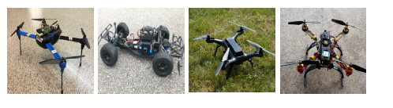

**Usenix Security2020**

Stealthy Tracking of Autonomous Vehicles with Cache Side Channels

本文提出了推算运行自适应蒙特卡洛定位（AMCL）算法的车辆的路线或位置的侧信道攻击，通过攻击软件

模型：

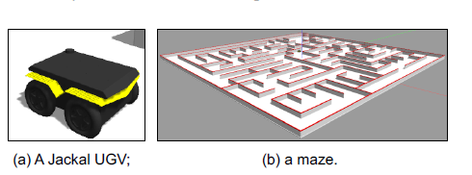

真实数据：

Oxford RobotCar dataset which is collected on a Nissan LEAF along a 10 km route around central Oxford, UK, from May 2014 to December 2015.

**Usenix Security2020**

SAVIOR: Securing Autonomous Vehicles with Robust Physical Invariants

本文针对了针对无人驾驶汽车和无人机的控制器上的防御架构

**两个真实的Avs：**

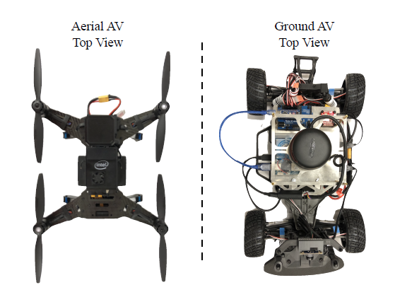

**ACSAC2019**

Out of Control: Stealthy Attacks Against Robotic Vehicles Protected by Control-based Techniques

提出了三种逃避控制算法检测的攻击是自动驾驶汽车出现故障。

**两种无人机：**

**ArduPilot无人驾驶平台**

